General properties for service interfaces at the case and document area

This standard was approved by the OIO-committee in December 2009

>

General characteristics of service interfaces of the case- and Document area
Published by:
IT & Telecom Agency

This standard can freely used by all. Quoted from the standard in other publications to the public, which Angie-fristede correctly kildehenvisning.

The standard is prepared by a working group Having The Reference Committee for case- and document the area.
Contact the OIO Committee: Project Rita Lützhøft
E-mail: rla@itst.dk.
Direct telephone: +45 3337 9242
Holsteinsgade 63
2100 Copenhagen Ø

Telephone: +45 3545 0000
Fax: +45 3545 0010

The publication is available on IT & Telecom Agency's website: http://www.itst.dk

General properties for service interfaces for case and document area

The Reference Committee for case- and Document area

18th December 2009

Purpose this document | 5
Background | 5
Genesis Process about standards | 6
Audience | 6
Reading Guide | 6
References | 7
Concepts and notation | 8
Notation | 9
Context and delineation | 10
Reference Architecture for case- and Document area | 10
Service Provider and Service Uses | 11
Service Interfaces | 13
Data Services | 13
Defending conditions | 14
Security and Rights | 14
Correlations between specifications | 14
Case | 15
Document | 15
Organization | 15
Classification | 16
File Structures | 17
Relationship to other specifications and standards | 17
General properties | 18
Object | 18
ID | 19
Object Type | 19
Dual History | 19
Registration | 19
Life cycle | 20
Impact | 20
Attributes | 21
Object Name | 22
Modes | 22
Relationship | 22
Operations | 24
Hændelsessbesked | 27
Notifications | 28
User Control Models - examples | 28
Inspection Services / Service Description | 29
Annex 1: Overview relevant documents | 31
Annex 2: Structure of the standard-return message | 32
Annex 3: Structure of the specific incident message | 33

Purpose of this document
The purpose of this paper is to describe the general transverse properties, applicable to all standards under the case and document area.

This document functions as a common reference framework for all standards under OIO committee for case and document.

This means that a number of terms, concepts and notation used in descriptions of the various standards are described in this document.

Background
The Reference Committee for Cases- and document the area was established in January 2009. The Committee is responsible for standardization of cases and document area within the state, regions and municipalities. Standardization is aimed at all IT solutions in need of file and document formation, i.e. it is directed both against case systems and ERMS Solutions.

The actual standardization work conducted by working groups established under OIO Committee.

The overall objective of standardization in OIO Committee the case and document on Board is to support greater coherence and clearer division of labor between ERMS solutions and case systems, and to create conditions for better and cheaper solutions in can better target the authorities' needs.

Reference Architecture for case-and document area [ref. 1] is a centrally based on the standardization of the area.

Important principles of standardization:

Division into ‘elements’ be setup independent groups around each of the areas designated as central in reference architecture, that is. case, document, file, organization, group, party, labor and workflow management. In addition, areas that constantly had to be prioritized by the OIO Committee.

The individual working groups draw up a specification for each of territory that describes what the interface should be able to support the business needs for data exchange, including the eligibility requirements for connections with other foreign territories.

Interfaces must be used by the ERMS- and the case systems to exhibit own data and use others' data.

The division into sub-components being handled by different but interdependent working means that it has been necessary to ensure a close coordination across working groups with regard to choice of description form and method. There is selected a method and a form that all workgroups must follow, including a decision on a number of general properties which will apply to all standards under the case and document field.

These are the general characteristics and requirements for all standards outlined in this paper.
Genesis Process about standards
Reference architecture for case and document area (ERMS) was published October 2008.

Standardization in FESD auspices stopped by. 31th December 2008. Current FESD standards are valid until being replaced by new ones.

The Reference Committee for Cases- and document the area was constituted in January 2009.

The common public FRS for ERMS solutions were published 23rd March 2009 (revised version was published May 27, 2009) [ref.2]. Public authorities can use it for their own supply in future. Requirements specification is based on reference architecture and assumes that in 2009 established standards of case, document, file structure (task) classification, organization and party.

It established working around case document archive structure, organization with participation of authorities and suppliers. There are average held six meetings in each working in period from February to September 2009. There is further work on draft classification in a small workgroup. There is 10 June held a joint across the groups. There is mid-June up a transverse working, to work with requirements / principles on how standards can be supported technically.

There has been a public pre hearing conference 24 June with the aim to inform about the work and invite a broad public debate on draft standards, including involvement of relevant views for the completion of standards before sending in public consultation.

Based on responses received in connection with pre hearing conference
have working groups revised the draft standards.

Six draft standard is published in public hearing 12 October to 13 November 2009

The received responses are treated in working and it is her sub-decided what changes should be incorporated into standards.

The final draft standards are presented OIO Board to approval in mid-December 2009.

Audience
The target audience for the standards under OIO committee for case and document authorities, consultants and suppliers, purchasers need advice-giving on and provides IT solutions in some degree manage files and documents management and documentation of workflows and fos management.

The target population represents both businesss and management insight and interest, and an IT system insight and interest in both a strategic perspective and in an operational perspective.

Reading Guide
This document is structured according to the following Structure

To the startgsvis describes the purpose of this paper, background for stan-dardiseringsarbejdet on file and document the area targeted by document, used references and læsevejwire to the document.

InConceptsand the notation establishes the concepts used in this and related documents. This section is primarily thought as a reference.

In the sectionContext and the delineation describes the context for this and confirm slægtede documents. The following describes the coupling to referencearkitektu-clean, the interaction between service provider, service use and serviceinterfa-ce, a definition of data service and its role, and a description of the relationships between the various business services. This title can be forpart read by both authorities, consultants and suppliers.

In the sectionGeneral properties describes the general characteristics of business objects of all types. The following describes in particular the operations of individual objects may be subjected. The general characteristics are fun-damentet by individual standards are based. The sectionanbefales therefore read of both authorities, consultants and suppliers.

InAnnex 1 An overview of the documents prepared in connection with the case and document, including over the standards
is endorsed by the OIO Board and a reference to supplementary material for more guidance and other relevant standarder.

References
This document applies to several other documents listed below. [1] Reference Architecture for Cases- And Document area1.
[2] The Joint Public ERMS FRS, version 0.2 May 20092

[3] Unique identifiers for digital objects, IT and Telecom Agency, 6th De-cember 20063.
[4] Service Oriented Architecture What and why, IT and Telecom Agency4.

Below are listed a list of terms used relateen the general properties.

Specific terms related to each area (case, document, file, organization and group) are described in specification for each area.

1 www.itst.dk/fesd/referencearkitektur/version3.0
2 http://www.oes.dk/sw52231.asp

3 http://digitaliser.dk/resource/324032
4 http://www.itst.dk/arkitektur-og-standarder/arkitektur/serviceorienteret- architecture / SOA / more-about-SOA /
Concepts and notation
Conceptual | Definition
Adaptor | A mechanism for transformation of an interface to another interface.
Attribute | Attribute is a session attribute with Impact, expressing an object's state.
Attribute Field | Attribute fields is the smallest items of information in objects. They typically contain simple values such as text, dates, integers or Enumeration.
Description | A textual explanation of the purpose and application that is complementary to other descriptions in sammenhÆn-gen. Subtotal explains all descriptions in a given context the whole relationship.
Designation | A map and possibly complex expressions together-sets description and is unique in consistency.
Terms | A set of conditions to be met to grant, modify or delete attributes, conditions, or relationships or to conduct operations.
Dual History | Properties of expression data over time in a registered design and effect perspective
Enumeration | A finite number of each unique textual beteg-term courses, each of which specifies a unique value.
Business Object | See Object.
Business Service | See Service
Generalization | A collection of properties that are similar to several of the object types. See also Specialization.
Interface | See Service Interface. Interface
ID | Identification, see also UUID.
Interface | See service interface
Cardinality | A expression for the number of relationships that must be created between a business object and foreign objects.
Object | A object defined by the justifies a looklv-alone service. Objects contain attributes to-stands and relationships other objects.
Operation | An action or proceeding that creates a well defined law result from one or more input parameters
Parameter | Input to or output operations, typically messages containing objects.
Reference | Referral another object through the declaration of the object UUID.
Relationships | A collection of references to related notes. Collection is limited by a cardinality.
Services | Services are an abstraction over forretningsfunktionali-ing and information made available for look-viceanvendere via a published viewrDeputy contract [Ref. 4].
Service Uses | Serviceanvendere are systems that receive, use and submit business objects through service interfaces. Employing Service uses service interfaces
Service Provider | Service providers are systems that receive, store and return all liabilities and import business objects of specific types through service interfaces. Service providers installing Service Interfaces and exhibits its operations through an interface.
Service Interface Interface between a service uses and a ser-vice provider. | Interface between a service and uses a service providers are systems that receive, storage suppliers and supply and liabilities and importing for-direction objects of specific types through service interfaces. Service Providers mounts service interfaces and exhibits its operations through an interface.
Specialization | A collection of properties that are unique to a particular  object type. See also Generalization
Specification | The specification is the service's external representation, realized in service implementations [ref. 4].
States The specification is the service's external representation is realized in serviceimplementationen [ref. 4]. | States are information elements of objects, corresponding of attributes, but for which it applies to their values can only belong to a finite number (Enumeration) and that value changes must take place after predetermined patterns (state tables).
UUID | Universal Unique Identification of business objects.
Values A description of the values that attributes tilstan- | they and relatives must take. Examples are texts of
Table 1

Notation
It noted that it generally tabulation are chosen to placebe-letter on the far left and heading to the far right. This is done to highlight and support the focus on the semantic content and the definition rather than name, which alone can be perceived as a short form and label.
Reference Architecture for case- and document area
Reference architecture for case-and Document area5 is the starting point and framework for work on the specification of standard interfaces under OIO-Committee for case- and document the area.

The reference architecture identifies a number of necessary and desirable fos-direction services6, as illustrated in figure below, which is needed when one wants to work with files and documents, whether there is an ERMS solution or a fagsystem.

Reference architecture is thus a means of making demands for theyinn the interface offered by the case, document and archive and to the interfaces that case, document and archive needs. The functionality will be expanded as the need arises.

It is a benchmark for Reference Architecture that the identified business services by 2015 may be supported partially or completely comepo components with service interfaces through the use of common public OIO standards.

The goal of standardization in OIO Committee for the case and document area is to realize and translate ANBemendations from reference architecture in a series of joint public OIO standardized interfaces that can support a more flexible interaction between ERMS and case systems.

5 www.itst.dk/fesd/referencearkitektur/version3.0
6 A business service is a logic function which is an essential part of the business itself or made disposal of business (eg. Book holderi). Every service is described with a logical interface. A servicebe-letter says nothing of how it performed. It can bema-nuelt, half-automatically or automatically, when automatic leveres of IT systems.
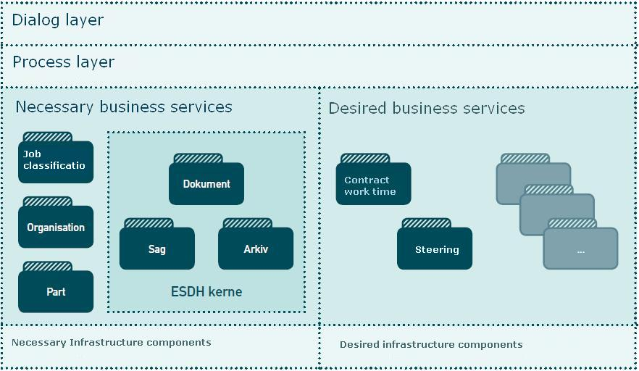
Figure 1 Necessary and the desirable business services

The figure contains a generic layered application model, consisting of layers: Dialogue, process, business services and infrastructure.

A more accurate term for the components of business layer is Forret-test services. It is this concept that will be used in furtherbe-letter.

A business is defined in this context as a whole or del-degree of automation of activities in a business service that is accessed through an interface or an integration, and can be controlled by a MICRo- Or macroflow in process layer. A business provides an interface that offers some operations targeted to store, locate or retrieve data through a series parameters as described in a specification model.

The interface can be implemented on new or existing solutions. So there is not a description of the implementation model or whenta model for the system. There will typically be a transformation between interfaces model specification and the concrete implementation model. Interfaces can be implemented in whole or in part, and could add additional functionality. This is clearer in the section Service Inspection / Service Description end of the document.

Service Provider and Service Uses
Service providers are systems that receive, store and deliver all liabilities and import business objects of specific types through service interfaces. Service Providers mounts service interfaces.

Service users are systems that receive, use and lodges business objects through service interfaces. Service users use service interfaces.
Systems typically act as either service or service user, but can also be both service providers and service user. This is illustrated in Figure 2

For example, an ESDH-system service provider of business objects and Action Document, while a case system service is used by business objects Case and Document. Case systems may themselves also be service provider of business objects Case and Document. This is the case when ESDH system handles the general case and document properties, while case systems handle the discipline-specific case and document properties.

Other
Serviceanven there

Fagsystem

Dialog

Process
Sa g

Data Access
D o k

ERMS- system

Dialog

Process
Sa g

Data Access
D o k

Figure 2 Systems as both Service Provider and the service uses

In Figure 2 case system acts both as Service user, since it consumes documents and case services from ESDH system and as service provider because it offers document and file services to other service uses.

Another use scenario service interface is related to a juxtaposition of the central key information from many different systems in a portal (eg. All relevant information about a child in a municipal assembly solution). Here a series fagsystemer, each of which handles different file types and documents act service for a matching entry, while acting service uses one or more central ERMS systems. Such a solution would specific file and document information will be stored in each of fagsystemerne while the general case and document information would be forwarded to and stored in the central ERMS systems.

Service Interfaces
Service Interfaces can be installed on existing systems (service-enabling) or embedded in new IT systems. Behind the interface there may be a transformation between the internal implementation and the standard specification This allows the creation of reusable and interoperability between systems.

Service Interfaces are system interfaces, as opposed to user interfaces. This means that the names used in the specifications, only exchanged between and interpreted by systems. Choice of names must be unambiguous and understandable support the exchange of data, but need not necessarily match the names used in user interfaces and read by end users. For the same reason a stronger focus on the elements properties and value the role rather than names.

The specification for each service interface describes the properties of the object, displayed through service interface, but handled in the underlying systems, including ESDH and / or case systems. This specification describes the general characteristics which the individual standards are based on.

Data Services
The here specified service interfaces exhibit alone operations data access (i.e. receiving, storing and supplying data objects), even services that deploy these service interfaces may contain a much greater functionality.

Close Case is such a process in service process layer because it includes the handling of context-specific business rules that cannot be inferred and interpreted from the data layer only, and is thus not an operation in the service interface Aid linked to the object Case. The equivalent operation on the data service layer is an Edit case that sets the state to complete.

Existing ESDH and case systems, which today offers a much richer functionality than just data access, including their own process and dialogue can usefully mount service interfaces in order to act as document and file containers for other systems.

Service interfaces can also reduce the possibility of working with transverse processes by making data available from the involved systems through these interfaces.

Example: A reporting system, which forms documents, must make documents available to the ESDH systems, through the reporting system, acting as service provider and mounting interface Document.
If the ESDH system must keep the documents, they will be imported via the interface Document on ESDH system, which operates customer service.

Process between service provider and service customer can be handled in many different ways (synchronous/asynchronous, push /pull, automatic/manual) and with different communication protocols.

Defence of conditions
Services defend the business rules associated with business objects.

Data Services defends the part of business rules associated with data integrity. These business rules are called conditions and include the pre-releases (Preconditions), which defends the service within the store. If the condition is not met, there will be an error message.

Conditions that goes beyond data integrity rules are not handled in data services but of service use are typically in process layer. The specific conditions set out in the individual specifications.

Security and rights
Service Interface Specifications must be installed on existing systems and the new systems or components. Service interface specifications must therefore be subject to the security properties that these systems possess.

The fundamental characteristic that all implementations of interface specifications must possess is that they must defend the object's integrity and confidentiality i.e., that objects must not be modified or displayed unintentionally.

If the interface is used by an existing ESDH System, then the interface can be subject to the user-rights management, which this system is currently using.

If the interface used in a context where security implementation is found at process level, it is this security model that must be respected.

If the interface is mounted on a separate component, the security may be implemented through the Danish profile of SAML 2.0.

The section “User Control Models examples” later in the next chapter provides examples of various user-right models which could be used in connection with implementation of interface specifications.

Contexts between specifications
The breakdown in business services is justified by a strategic desire to create smaller systems without duplication of functionality and built for integration.

The various specifications are interdependent, as described below. There are relationships between them by their objects having relations to each other; called object references.

It is not assumed that a given business has only one implementation of a service interface. If there are multiple interfaces, that handle the same types of objects, it is required that the organization has a global view (in the form of UDDI catalog) over the various business services. This is not solved with the referring specifications.

Each specification handles one or more object types and references to other object types.

Case
Service interface provides the following object types and relationships.

Description | Object Type
A collection of related documents and other connected information in its entirety used to document a workflow, typically for administrative purposes, including decision making. | Case

Relationship | Object Type
Document, handling the files | Document
File Structure, which handles the files of the associated Case | Archive
Part, who handle litigants | Part
Classification handlers proceedings classification scheme | Class
Organization that handles case actors | Actor

Table 2

Document
Service interface provides the following object types and relationships.

Description | Object Type
Documents composed of distinct collections of information, in known structures of known formats. Documents can contain text, drawings, graphics, photographs, video, voice and / or much else. | Document

Relationship | Object Type
Organization that handles document actors | Actor
Part, who handle document parties | Part
Classification, which handle the document classification scheme | Class
Case handling the cases for which the documents included in | Action
File Structure, which handles the files of the associated Case | Archives

Organization
The Service interface provides (distributes) the following object types and relations. All the object types from organization are called Actors (as a common name).

Description | Object Type
Organization is the only legal organization (legal entity). It can be an authority (ministry, agency or municipality) or a company (with CVR number). | Organization
An organizational unit may be attached to an organization directly, indirectly or not at all. Such a device may be a department, section, office, committee, project team, steering group, class, teams and the like.  An organizational unit can be used as a generic term for an organizational view into the organization. | Organization Unit (OrgEnhed)
IT systems or configuration items, as appropriate to record something about the organization. | IT system
The concept of organizational feature used on a feature or role as an actor in relation to the other players. | Organizational function (OrgFunktion)
User is an actor type that represents a user identity including a certificate. It may be a person or an IT system that operates a user. | User
Interests are perceiving as a named collection of individuals who are not a legal entity. Thus booked concept organization into a formal organization. But otherwise a shared interest could have the same properties as an organization. | Interests

Relationship | Object Type
Classification, which handles its business, duties, authority type, device type, computer system type, user type | Class

Table 4

It is noted that object type User incorporated as reference in all other specifications, because it is the actor that is used when one detects objects.

Classification
Service interface provides the following object types and relationships.

Description | Object Type
Here attached information, which together describe the various systems used for classification. Should such be accessed from the Archives, since Archive refers to classifications system | Classification
This describes each facet (dimension) included in classification system. It contains information on building in lists hierarchy, etc. | Facet
Class includes practical classes. These classes can be ordered hierarchically and therefore have over-and underem-tions. Classes can also also have contiguous classes (references), also called related classes. Must be able to be accessed eg in the markup of files and objectively States. | Class

Relationship | Object Type
Specifies the organizational actor who owns, is the editor or responsible for the classification objects | Actor
The reference to other classification systems classes (map-test) | Class

Table 5

In addition, the classification used in many other contexts, for example. to to accommodate other classification systems than those traditionally used for file and document area.

Archive Structure
Specification File Structure used to get an overview of the proposed emergence of archive each organization / authority applies. File Structure to be used by the specifications and Action Document to to describe the which file to their business objects are located, hence the common characteristics of such a collection of files and documents in relation to archive period, delivery, cancellation, etc..

Service provider interface following object types and relationships.
Description | Object Type
An archive contains material classified by one and the same classification system. | Archive

Relationship | Object Type
Classification to indicate the scheme followed by the archive. | Classification
Organization to identify the roles various actors can have in compared to archive, for example. who has responsibility for the records | Actor

Table 6

Consistency to other specifications and standards
The following standards are relevant compared to standards under the Interoperability Framework Committee for case and document:

Conceptual Model for user management
Recommendation to a general event message
The next standard, which is scheduled standardized auspices of OIO Committee for case and document are:

workflow part (CPR)
There is also a concern that the general characteristics can also be used in the address, authority, business (CVR), a source of law, etc... These records do not have the general properties are reviewed below. Until this is in place, used the keys to these registers offer. According to individual specifications.

In the following describes the general characteristics that apply for all service interface specifications
The figure below shows the main elements of an object.

Objects are characterized by being composed of attributes, conditions and relationships other objects.

Attributes, states and relations can change value over time indicating element effect.

Objects handled by operations. Once a user has performed an operation that affects an object, a registration is formed.

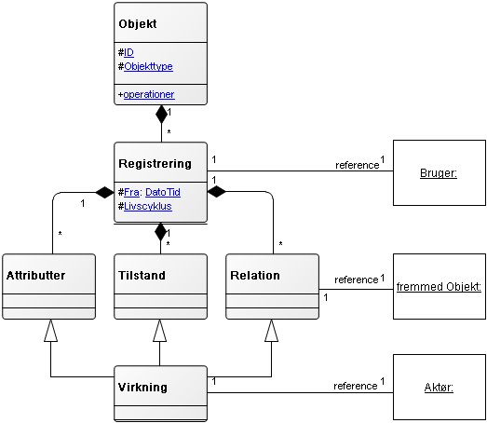

Figure 3

The elements elaborated below.

Object
A object has a unique identification and are of a particular type.

Description | Values | Obl | Designation
Unchangeable, informationless and universally unique identifiers of an object | UUID | Yes | ID

ID
ID contains objects identification.

Object Identification must comply with the standard for the identification of digital objects (Ref.3). This means, among second, that identification is unchangeable, meaningless and universally unique.

Object ID is therefore limited by the value set UUID.

Unchangeable means that identification ensures technical identification of DA projects throughout their life, even when they are distributed in different services in which they are imported.

Informationless means that the identification does not contain information and thereby remain unchangeable.

Universally unique means that identification cannot occur more than once, either in same instance of a service or across multiple bodies set-looks the same or different services, nor over time.

Conditions:

ID must be assigned value when creating the object. ID can never change the value after creation.
Object Type
Object type is a type name for the object.

Specifications defines the following types of objects: Case (case file), Document, Archive, Organization, OrgEnhed (Eq organization unit), OrgFunktion (eq Organisation function ~ department), IT system, User, common interest, clasification, facet, class.

In addition, relationships with objects not yet defined: Part, address, email address expenses etc.

Dual History
The characteristics of dual history put service uses in a position to view and process objects in two independent time perspectives, called the registration and effect.

Registration perspective indicates the times when the entire object with its attributes, conditions and relationships recorded.

Registration
At every operation that modifies objects, attributes, conditions, or relationships (Create, Import, Right, Passive, and Delete), create an object registration. These operations, except maintenance work on a copy of the original object registration.

To manage objects registration periods, an item with the following fields should be used:

Description | Values | Designation
Date and time of registration |  | From
Object's technical progress in relation to existence.  The object is created.  The object is imported | Created  Imported | Lifecycle
Reference to the actor who made this registration. | UUID | Actor

Element attached to the object in its entirety. At each registration created a new Object Relation above structure. It may not be possible to modify a previous registration. The purpose of registration is to document the contents of an object at any time.

Each registration must contain a UUID for the user. The service inspection/description must provide information about how that UUID has been obtained

This feature can be implemented in a traditional log or in a database, depending on the object's characteristics and business needs, for example, to demonstrate the calculations, both the data entered into the calculations and the result as a calculation arrived at.

Life cycle
Field Life Cycle contains information about objects creation and control. The object is controlled by the service being created, imported, passivated or deleted object.

Created and imported objects can still be changed. Passivated and deleted items cannot be changed. Deleted objects correspond to locally deleted items. It is possible to import a passive object again.

Conditions:
Life cycle changed mode of operations in the respective services. It is however this context appropriate to illustrate the lifecycle states and mode switching.

class Domain Objects

Created Deleted (logically)

Pasivated Imported
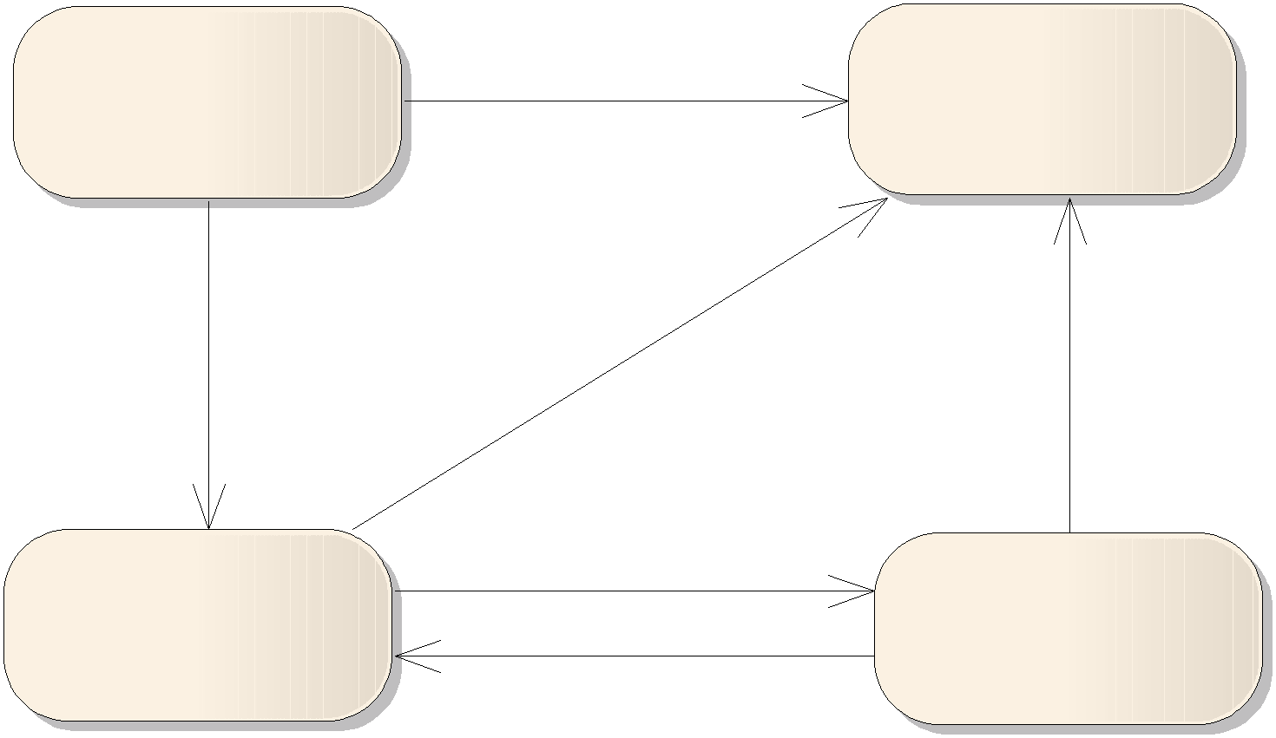

Impact
Impact perspective indicates the time periods in which the values of object’s states, attributes, conditions and relationships have impact.

For example, an object of type Document has an attribute named Title, and Title is an attribute in the Document Properties. The contents of this attribute may change over time.

Changes can be made both in the time and back in time. Time period is indicated typically by the actor who uses business service but may at their exclusion, be replaced by default values.

Time periods may be subject to temporal gaps, but may not have temporal overlap, as such creates ambiguity. Timing holes, by contrast, shows a lack of knowledge in the respective periods and therefore acceptable.

To manage object impact periods, use an element with the following fields:

Description | Values | Designation
Starting date and time the impact period. | Datetime | From
Final date and time the impact period. | Datetime | To
Reference to the actor, which entails the implementation of impact period. | UUID | Actor
Any notice, identifying the reason for the launch of the relevant impact period. | Text | Note

Table 7

Element are attached to the object's attributes (not each), to each of the object’s states and to each of the object’s relationships.

Objects constructed of multiple attributes, multiple modes and multiple relationships, as objects change over time. After each change, add a new set of attributes, conditions and/or relationships, and the above structure. Objects that have undergone many changes over time contain more sets of attributes, conditions and relationships than the objects which have undergone little change.

If you do not need effects, set ‘From’ to ‘-infinity’ and ‘To’ to ‘+infinity’.

Attributes
Attributes is a collection of attribute fields. Attribute can, for example, hold the titles of cases or letter dates on documents.

Objects of different object types have different attributes.

Attribute is constrained by values, including texts, dates, numbers, object types and others. This means that attributes can only assume values that are described in their respective values as specified in each individual specification.

Attributes and their attribute fields can be further limited by conditions that govern how they each have assigned values.
Attributes may change value over time indicating element effect. Objects have at least one attribute with the following attributes:

Description Values Obl Designation

User friendly textual identification of object.
Object Name may have a different name for the document, for example. title.
The period during which the value of the attribute is applied

Text Yes Object Name

Effect Yes Effect

Table 8

Object Name
Object Name attribute contains objects user-facing identification. Object Name may have a different name in the various specifications but attribute has the same properties (mandatory).

Modes
Mode represents the object status. Mode are dependent on the business context and be actively pursued by the actor. For example, a classification can be published or unpublished, and an organization may be active or inactive.
Each specification indicates which states the object can be in.
Modes can change value over time with the use of the pelement effect.
In this context, the operator is the actor who causes change of state. The note can be used for to justify the status changed.

Modes may be attached to conditions that govern how they can be assigned values. For example describes a state requirement that a file may be placed in Status Notification Agreed, if it has reached the status Review.

Relationship
An object will have multiple relationships; one for each reference to another object. Relation uses the item impact, and thus can be attached to a note for each reference. The references are stored with object7.

For example, relate a case to an archive in which the case file is stored. This is illustrated in Figure 3. If the case switches to another archive at a given time, this will cause a new instance of Relation with a new effect period, and with reference to the new archive.

7. See Concepts and notation for a deepening of the gap between ‘reference’ and ‘relation’

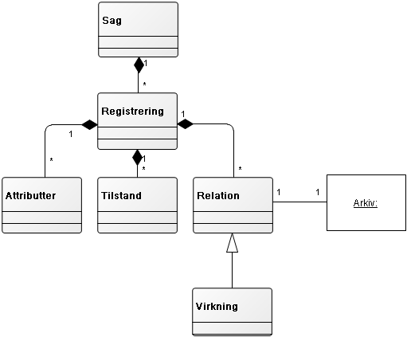
Figure 5

In the example, the object Sag (Case file) has reference to Archive, but the Archive has no reference to the Case file.

The relationship can only relate objects of specific types and only specific numbers, delimited by an interval. If a relationship is, for example, limited by object type Actor with cardinality 0..1, the relationship can only reference actors and never more than one instance at the same time period.

Relationship is further limited by conditions that govern how they can be given references. For example describes a related condition, that a case file cannot be assigned additional documents after the case is brought in mode ‘Afsluttet’ (Completed).

Relationships are modeled with this structure to make way for impact, impact player and note, and it is also prepared in order to add references to new object types when further requirements arises in the future.

The relationship between object types allows loose coupling between objects from other specifications. At the time when the relationship is formed, it is assumed that the right ID, which is added as a reference is found. But when the reference is added, there is no guarantee that the object can be modified or deleted at a later time in the foreign service.

To compensate for the lack of reference integrity, objects must be marked as deleted (~not physically be deleted) and communicate this with an event message. Furthermore, the object must – if possible - be able to refer to another object as deputy.

Certain items must be physically removed from service under different rules, and the responsible (service?) must ensure that this is also observed. If detection perspective is used (see later), you will find the original object as it looked on a given recording time, and can therefore use it as evidence.

If the organization does not have access to a specification related object types, it can be compensated for with a deputy (so called proxy).

If, for example classification has been implemented but no organization, one must compensate for that lack of reference to the actor. This can be done by the deputy provides an ID, which maps to the organizational system you are using. The same applies if you want to use other relations with foreign objects that do not yet have those properties. The rationale for this is that uniqueness (UUID) for identification is a prerequisite for interoperability. When we later implement organization we will be able to import the IDs that you have already used.

In principle the relationship only contains reference to the second object. In practice, you will need to save information so that do not have to look them up every time it shows the objects. A reference to a class in a classification system consist of UUID for the object. This must be informationless and therefore will in practice need to save e.g. class identifier and a name. There is therefore a temporary memory (cache), which could be updated at intervals e.g. based on event messages.

Operations
Objects handled by the following operations:

Description | Input | Output | parameters | Designation
Creates a new | Object Create | Object |  | Create
Object |  | Standard Return
Importing an | Object Import | Object |  | Import
object |  | Standard Return
Find and return | ObjectID | Object | VirkTid | Read
Object (Always latest registration) |  | Standard Return
Edits an object (Always latest registration) | ObjektRet | Object Standard Return |  | Edit
Deletes (logically) one | ObjektID | Object |  | Delete
Object (Always latest Registration) |  | Standard Return
Liabilities an | ObjektID | Object |  | Liabilities
Object (Always latest registration) |  | Standard Return
Finder and return | Search Criteria | IDListe | VirkTid | Search
several objects that match the search criteria |  | Standard Return | RegTid
Find and return several | IDListe | Object List | VirkTid | List
Objects That match the ID List supplied |  | Standard Return | RegTid
Table 11

Inputs
Input contains a structure with an object, its parts or search criteria. The structure of the input message is defined as an annex to each specification and can be different versions.

Output
If the operation is completed, contains the output of a structure with the result of the operation. The structure of OutputCommunication defined as
Annex to each specification and can have different versions.

Standard Return
Standard Returns contain the return codes in form of information, warnings and error messages, and Standard Returns are always included as output, because the inside provides information on whether the operation is completed or not, including the used default values. Structure for Standard Return Notice shall be annexed to the general characteristics and will be common to all specifications.

Parameters
Parameters are really into input structure, but it will not be any implementations which can work with these parameters. VirkTid and RegTid may contain blank, a date or a time period. If RegTid is blank, get the latest registration. If VirkTid is blank, search all effect periods.

Create
The operation creates a new object from the input structure. Input must meet the conditions for the object's attributes, modes and relations cf. service interface specification for each object type, otherwise returns an error message.
The service’s responsibility is to assign ID, provide a record of the life cycle mode 'Created' and fill in default values. Object in its entirety is returned in output.

Import
The operation creates a new object on the basis of inputs in the same manner as Create, but with the difference that the object ID must be part of the input. The business rationale for the import operation is that an object must be found in different services with content that is updated asynchronously.

Input must meet the conditions for the object's attributes, modes and relations cf.service interface specification for each object type, otherwise returns an error message.

If the object already exists in the service given an error message,
Otherwise, the service shall constitute a registration with lifecycle status ‘Imported’ and fill in default values and return the object in the output.

Read
Operation takes an object from the input structure ObjektID, which contains only ID.

If the object does not exist in the service, there should be an error message. It is the service’s responsibility to return the most recent registration of Object.

If the parameter VirkTid is specified, the object elements will be filtered so that only those elements that have impact on VirkTid, is returned. If no elements have effects on VirkTid, give notice.

Edit
The operation notifies an existing object. Forms a new registration of the object.

If the object does not exist in the service, given an error message. Output must meet the conditions for the object's attributes, modes and relations cf. service interface specification for each object type, otherwise returns an error message.

Input must contain the ID and the elements that must change. Unchanged elements and lists of items need not be included in ObjectEdit but it gives no errors.

If the contents of a list of items are addressed, the entire new list of elements is in ObjectRight.

If ObjektEdit is empty or contains the same elements as the latest registration, produced no new registration - and provide a return code with a warning.

The service responsibility is to return the new registration of object.

Delete
The operation forms a new registration of object ObjectID with lifecycle status Deleted. The business rationale for the delete operation is to allow for (logical) to remove objects that you no longer need.

If the object does not exist in the service, give an error message, otherwise the service return the new registration object.

Deactivate
The operation forms a new registration of Object ObjektID with lifecycle status Passive. The business rationale for deactivate operation is to distinguish between (logically) deleted and passive objects. A passive object can still be used, but is not maintained.

If the object does not exist in the service, given an error message, otherwise the service should return the new registration of the object.

Search
The operation returns a list of identifiers (IDList) based on a search criteria. There may be many different search criteria structures.

Common to them is that they are working on all objects in service and all registrations of objects.
The criteria can be specified for the whole object or selected elements of object. That is both structured and free text search can be supported.
You can filter the registration dates and efficacy dates there be included with the parameters RegTid and VirkTid.
If no objects match the search criterion, information about this shall be given. If more objects satisfy the search criterion, than the service can handle, a warning about this shall be given.
The service’s responsibility is to return an IDList with Objects.

List
The operation returns a list of objects specified in IDList. There may be many predefined Combined Object List structures. There can be sorting and separation into pages in lists.

IDListe ID must contain at least one Object otherwise returns an error. IDListe will typically be output from a search.

You can filter the registration dates and effective dates to be included with the parameters RegTid and VirkTid. If RegTid not specified, the search for recent records. If VirkTid not specified, searched all impact periods.

The service responsibility to return an Object List.

Event Messages must be restored by performing a search and a list of changes to the attributes, conditions and relationships.

Event Messages
There shall be formed a specific event message each time an object changed. The format of this message shall be annexed to each list.

The specific event message associated with a general event message, which applies to all event messages and functions as envelope. The general event message contains information use for handling the messages in incident distributers and described in detail in Recommendations for a general event message.8

The specific event messages general characteristics are described here.
When a business object life cycle changes (see below) or there is changes in object's attribute, condition or relations must form a specific event message.

Event Message must indicate the object's identification and its object type, time of change and sufficient information for a subscription expression example. related to classification and organization actor. It is not intended that the whole object will be sent with the event message.

⁸ http://digitaliser.dk/resource/431101/artefact/Anbefaling_generel_h% c3%a6ndelsesbesked.pdf

If a subscriber wants more information than what the event message contains, the subscriber must be able to turn the object into the service. The rationale for this is that different viewers will need different information, and will have different rights in relation to the object. This means that it is a balance to weigh the contents of event message between the necessary and the right sound. Therefore it would also be up to a contractual relationship between service and incident manifold
to decide who will be able to subscribe to a particular type, including at what times, incident messages posted.

Example
It is planned to make a change in the organization change with effect from a given date in the future and it is required that the involved personell doesn't know about this before it takes effect. Therefore it should be possible to restrict access to these event messages through subscription term which includes state and effect.

Timing Modes understood as state changes due to 'time goes' is handled by forming the state with a future effective date. This future state of change must be included in an event message.
When the designated impact point (future date and time) occurs, the object should be in the (new) described condition, without a (new) manual registration.

Example
If you have sent a document into hearing (hearing is a process where stakeholders have time to read and comment) and the document is to be considered as 'approved' if no objections are raised within a certain time, we can provide state at that specific time (hearing period due date). If there are no objections, we can change the mode or remove it. (This example is actually wrong, because 'remove it' is only relevant if there ARE objections).

When you deploy a service interface specification you must therefore make a deal with an incident broker (I don't know if we call it that. But the mechanism that works as post office between the system SENDING a message and the system that RECIEVES a message is very central in the event message architecture. In any case we must come up with a good English word here) that can receive event messages related to the service objects. It is through the incident broker that different stakeholders (systems or users) can subscribe to event messages and initiate a workflow on that basis.

Subscription and event manifold is not a part of this specification.

Notifications
If you want to put an object in memory to get an advance notice at any given time (even if there is no change of state), you must create an event message, without the object necessarily been changed. This event message must have a future effective date and the user who needs to be warned must subscribe to that event message (In this case we can subscribe to a 'dummy event'. There is no real event but I create one (that doesn't change anything) to be able to get the message).

User Control Models - Examples
This section contains examples of how to build rights management for access to objects that the service handles. The actual management and enforcement is not part of specifications.
A user management rights are defined by an action at a objekt.⁹ Rights are grouped in user management roles. In this context, the after mentioned operations correspond to actions.

The question is how to identify the body or objects that must be covered by user management right. There is of course possible to define in relation to different types of objects, but other information will be used for demarcation.

One possibility is to use a relation to an organizational actor – e.g. to the actor that owns the object. This can be done from user management rules that could include organizational structure.

Another option is to use a relation to a classification system that provides ‘security labels’ in a hierarchy. As a user you get a role that is defined as one or more actions on objects related to a particular class that is created for user management purposes. Running the operation ‘Create’ must be the object associated with the class that you have been awarded with the right. Then everyone who has rights to the same class could perform the acts included in the entitlement.

There are special right circumstances related to objects maintained in one service and distributed and imported in other services, where they are read-only. E.g. the buyer of a classification system which FORM like this system widely used but not changed inadvertently.

In such cases there should only be given read access to the distributed objects. When using an event message is notified of a change that will be in a process to retrieve the new registration and import it, without changing the content of the object. Prerequisite for these imports is that the original panel is made passive.

Services Inspection / Service Description
Service inspection is a measure of how much of the interface specification is implemented. Thus, it is a ‘measure’ of the implementation of the specification.

The service will offer a description of its implementation – either in the form of a special operation service inspection - or as an accessible description, as a service uses to avail a service contract.

Service description should in itself versions and refer to the version of the service specification, service description relate to. Where possible, the interface offers backward compatibility.

Properties which are not supported by underlying service / system (implementation) may in some extent fed through service interfaces, or may be omitted if not mandatory10. For example, not mandatory that

9 See conceptual model for user management
10 The supplier must be able to explain how big a part of the standard is implemented.

service interface implements double history, but it must be clear from the service description on how the service-user to behave eg. that service-user himself must document object's content that the objects looked when they were used and the service-user must carry out the audit trail.

Examples of input properties Service Interfaces are the property of expressing double history. Systems that are not even handle object's data, over time; can usefully add these features via the service interface11.

Moreover, it is possible for suppliers to provide additional functionalities- beyond the operations listed in specification.

Examples of excluded properties are operations that are not implemented, if there is a business need for them. For example, it may be chosen that a case system implement the operations Find, Read and List of applied to cases and gives thus other systems the ability to retrieve case information, but not implement operations Create, Change or Delete, thereby excluding other systems from using it as a case container.

Service inspection shall also include reference to the versions of operation messages used as input / output.

Service inspection shall include an overview of the event messages, as service user could subscribe to.

Services inspection should describe what specific classification systems used for the value amount for the service attributes.

Services inspection (service description) must explain user right circumstances:

How authenticated user, for example. with a SAML token with a logon or codes?

How is the user registered as an actor ? 1) with UUID for organizational actor 'user', 2) SAML Token, or 3) by mapping to logon code?

(The 'service inspection' must provide information about how the object 'actor' has been defined. Three options.)

What roles the user may be assigned so that the rights model may be enforced (operations and object boundaries)?
Are the roles of the service known, or must they be enclosed as a SAML Certificate?
Making service audit trails (logs) in reading and how do the security administrators access the log (via operation or sent on paper)?

11 In developing the standards under the Interoperability Framework Committee for case and document who completed a Proof of Concept (PoC) project that demonstrates how the dual history can be added an already functioning document management system in the service interface.
The following list gives an overview of the documents prepared in connection with file and document area12.

Standards approved of OIO Committee:
- Generelle egenskaber for serviceinterfaces på sags- og dokumentområdet “ December 2009
- ”Specifikation af serviceinterface for sag” , December 2009
- ”Specifikation af serviceinterface for dokument” , december 2009
- ”Specifikation af serviceinterface for arkivstruktur” , december 2009
- ”Specifikation af serviceinterface for klassifikation” , december 2009
- ”Specifikation af serviceinterface for organisation” , december 2009

Additional material:
- ”Vejledning om ikke-funktionelle krav vedrørende serviceinterfaces på sags- og dokumentområdet” (”Guidance on non-functional requirements for service interfaces on file and document area”) , december 2009
- ”Eksempel på brug af generelle egenskaber - et konkret eksempel på en informationsmodel (Dokument)” (”Example of use of general characteristics - a concrete example of an information model (document)”), december 2009

Linked to POC-work (Proof of Concept):
- There a wiki with documentation from a POC. Interested parties can access the wiki one, contact NITA at sagogdokument@itst.dk

Referral relevant material developed in other contexts:
- “Begrebsmodel for brugerstyring” (”Conceptual Model for User Management”), December 2009
- ”Anbefaling til generel hændelsesbesked” (”Recommendation for general event message”), december 2009

12 As at 11th December 2009

Annex incorporated.

(OIOXML in preparation p.t.)

Annex incorporated.

(OIOXML in preparation p.t.)

